Aim: Design and develop custom Application (Mini Project) using Salesforce Cloud.

Objective:

* To design and develop custom Application (Mini Project) using Salesforce Cloud.
* To understand and use cloud computing services for building web applications

Theory:

Salesforce is the leader in cloud computing, offering applications for all aspects of your business, including CRM, sales, ERP, customer service, marketing automation, business analytics, mobile application building, and much more. And it all works on the same, connected platform, drawing from the same customer data. with Sales Cloud, you get the sales automation features you need all in one place. Sales Cloud empowers businesses to manage leads, track progress, and automate sales processes with ease.

Salesforce Org: The cloud computing space offered to you or your organization by Force.com is called Salesforce org. It is also called Salesforce environment. Developers can create custom Salesforce Apps, objects, workflows, data sharing rules, Visualforce pages and Apex coding on top of Salesforce Org.

Pre-requisite: First Start your 30-day free trial of the world’s leading CRM

https://www.salesforce.com/eu/form/signup/freetrial-sales-pe/

Then follow the steps to create application using salesforce.

Salesforce Lightning experience is a modern, fast, and intelligent user interface built with proven Salesforce1 Mobile App technology. It combines Lightning Designing System (LDS), Lightning app builder and Lightning Components to create modern enterprise applications.

To enable the lightning experience in your Salesforce org, ****the steps are as follows****

Step-1: Click on Lightning Experience

Step-2: Click on Setup and select Setup for current App. Step-3:

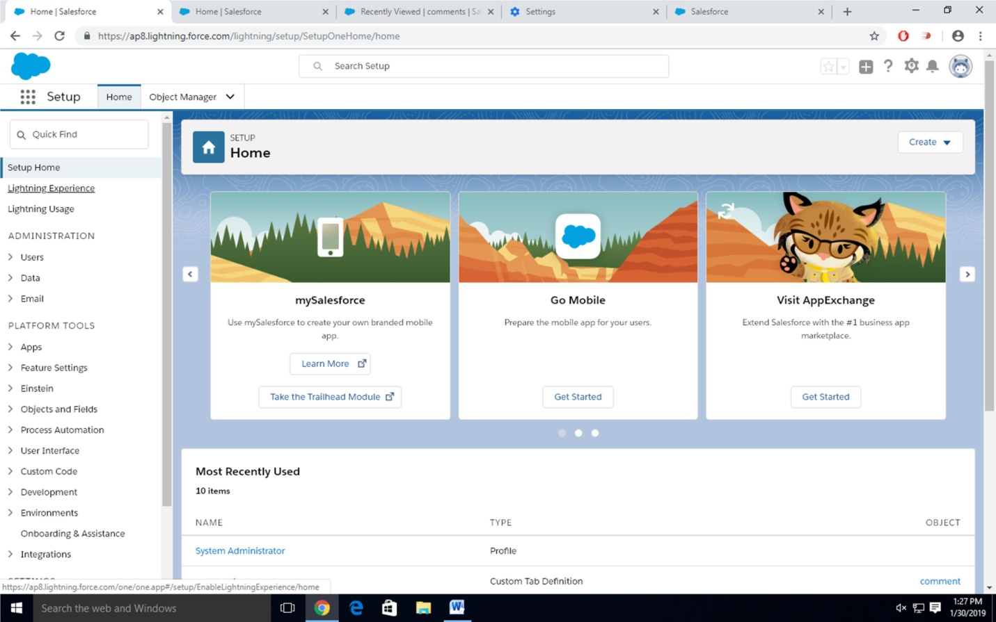

Click on Create an Object

So Click on Object Manager Tab next to Home Tab Click on Create –Custom Object

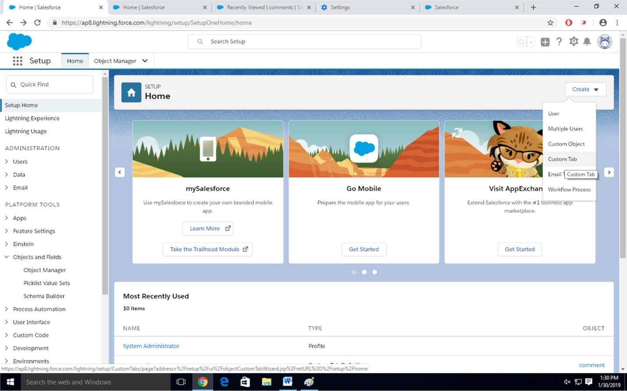

Step-4 New custom object page Open Label as a-Comment

Plural label- comments

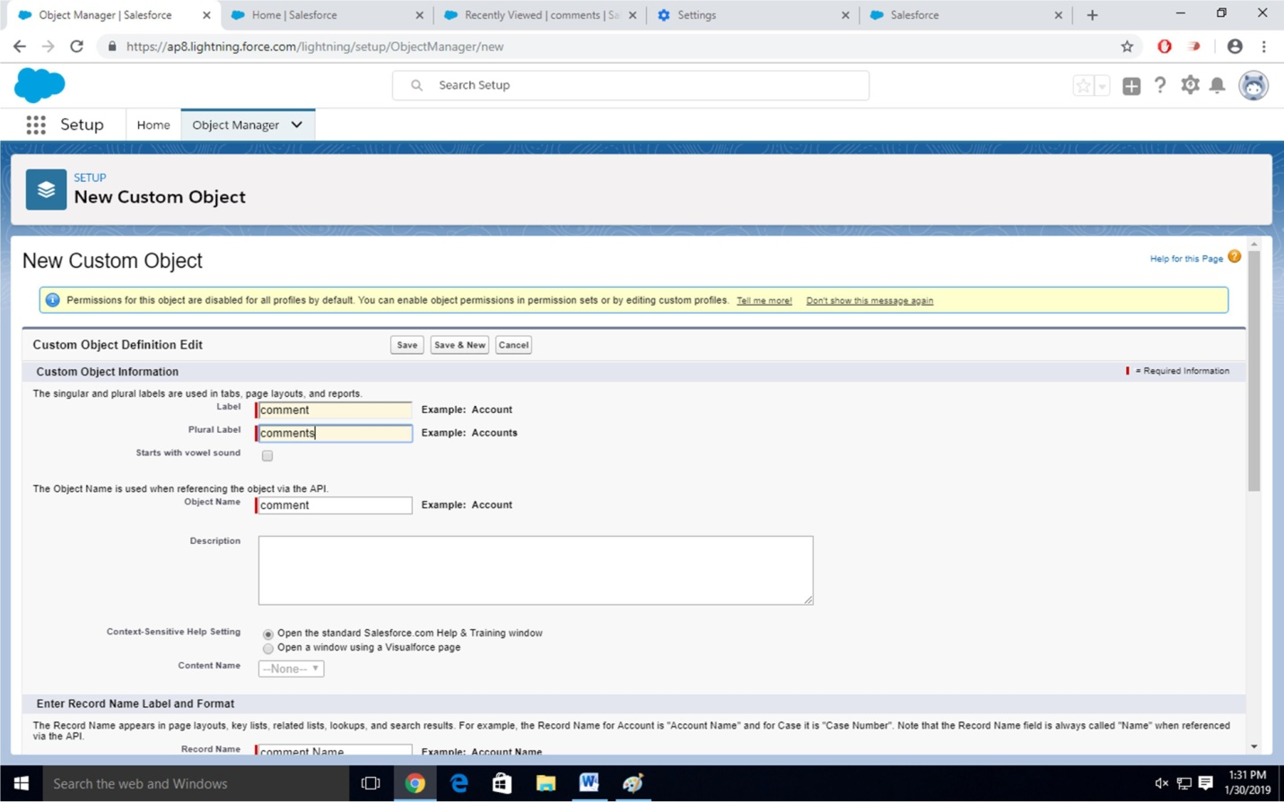

Give Record Name as –comment name Data type- text

Select Allow Reports Check Box Click on Save

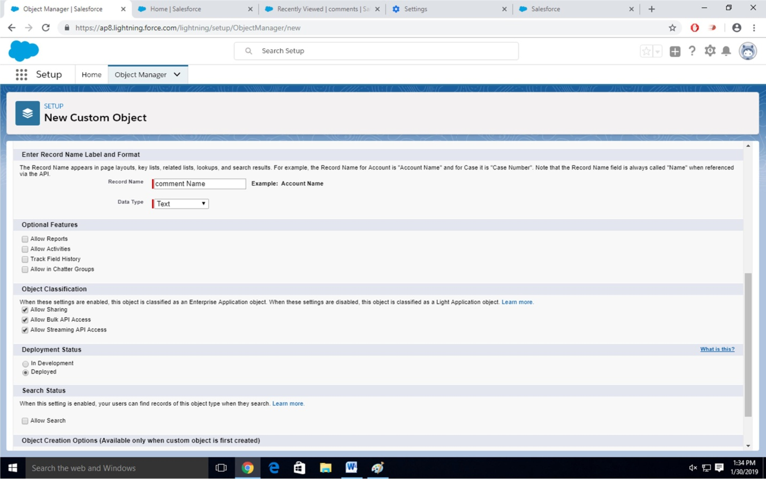

Step-5

Click on Home-Search Tabs in Quick search Select Custom Object-Click on New

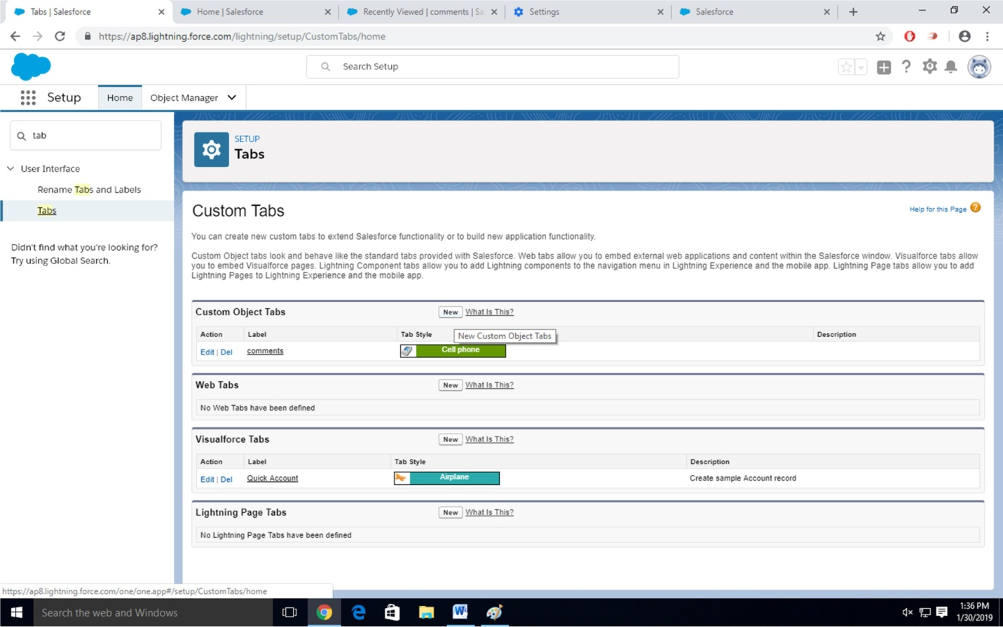

Step-6

For Object Select Comment For Tab Style Select Any Icon

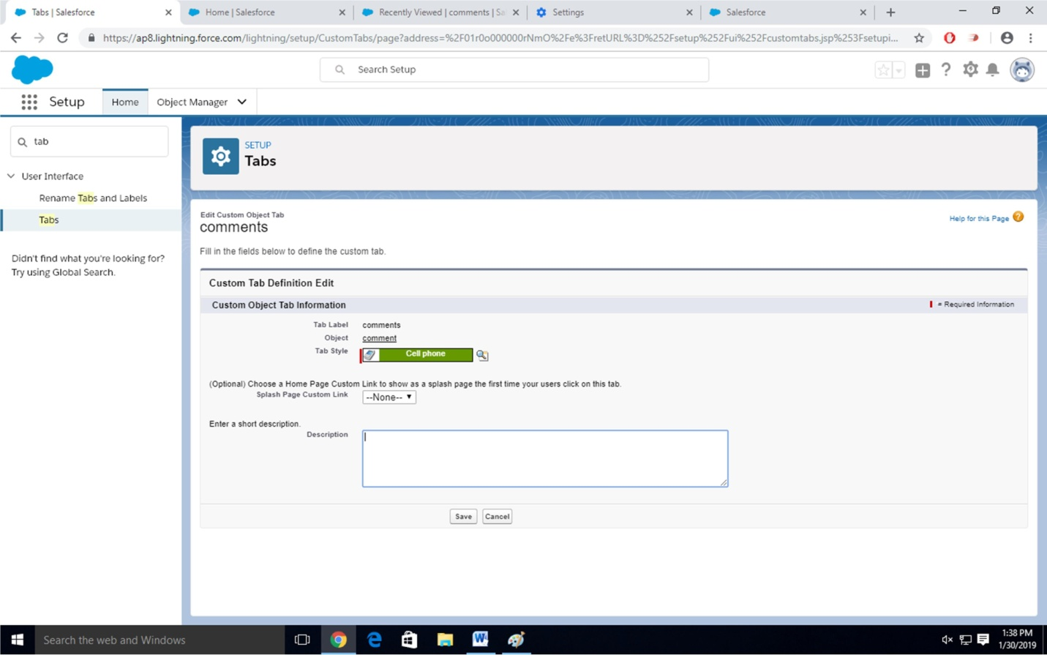

Click-Next-Next-Save Step-7

Search App Manager in Quick Search and select app manager

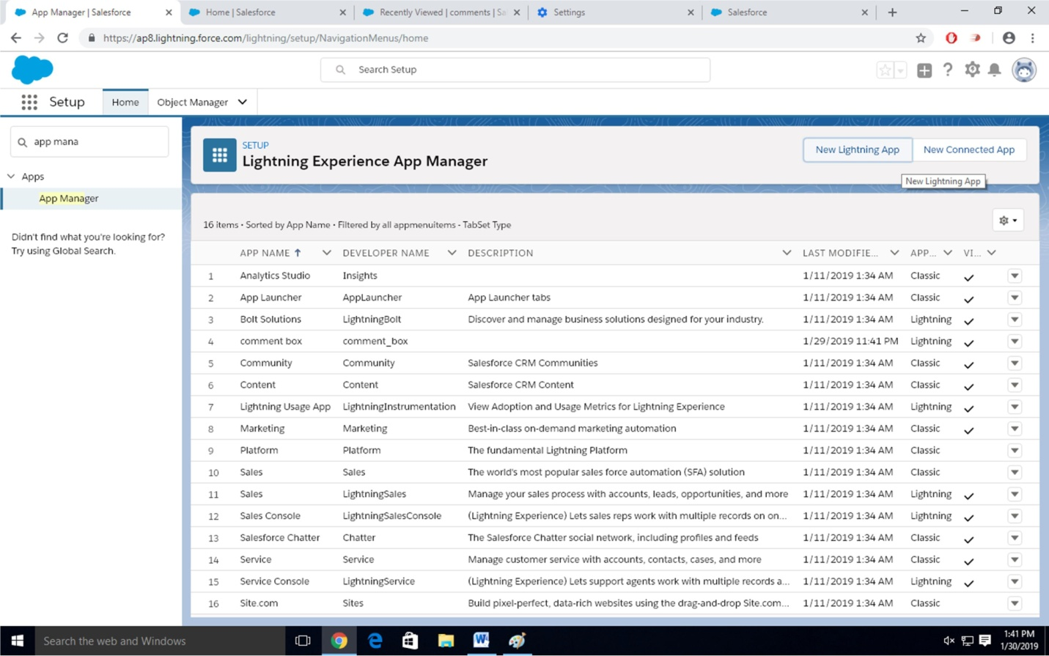

Enter name to app name

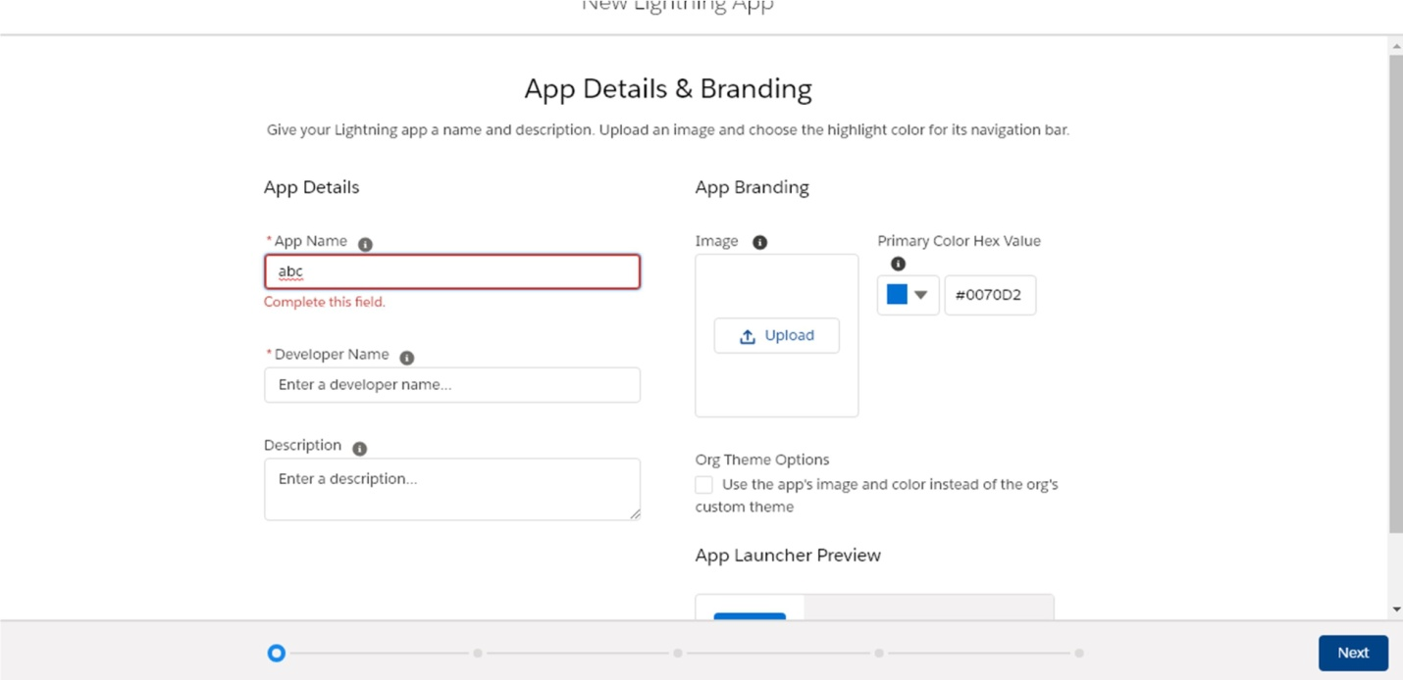

Click on Next-Next-Next.

Select Items (Contacts,Comment) Click on Next

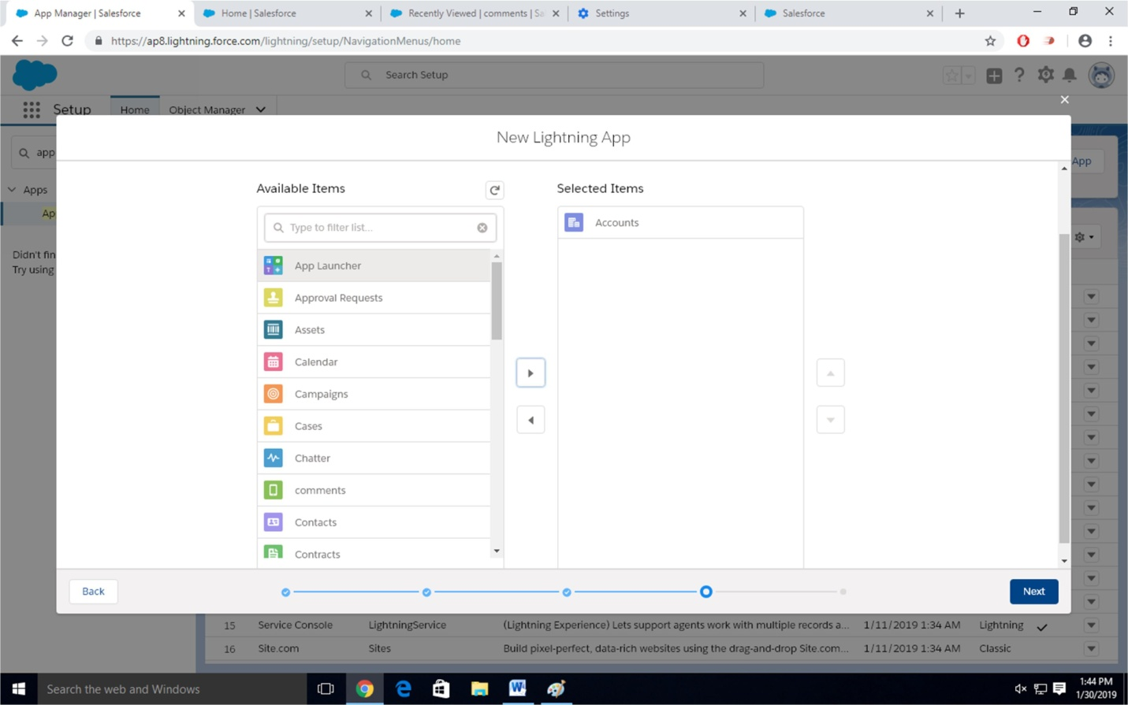

Step-8

Select Profiles ( System Administrator) and move to selected profile. Click on Save and Finish.

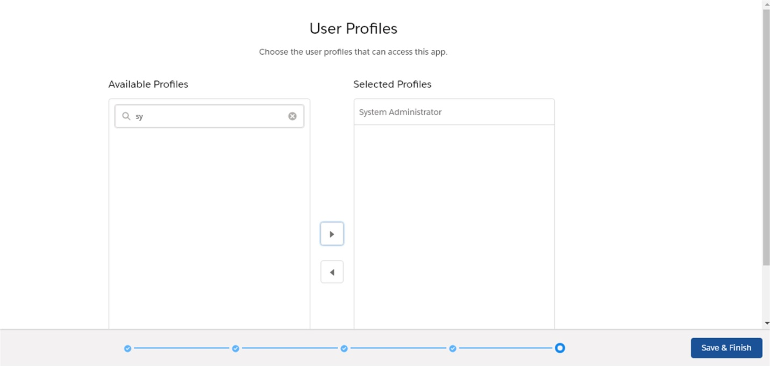

Step-9

Click on App Launcher  Symbol and Select Comment Box App

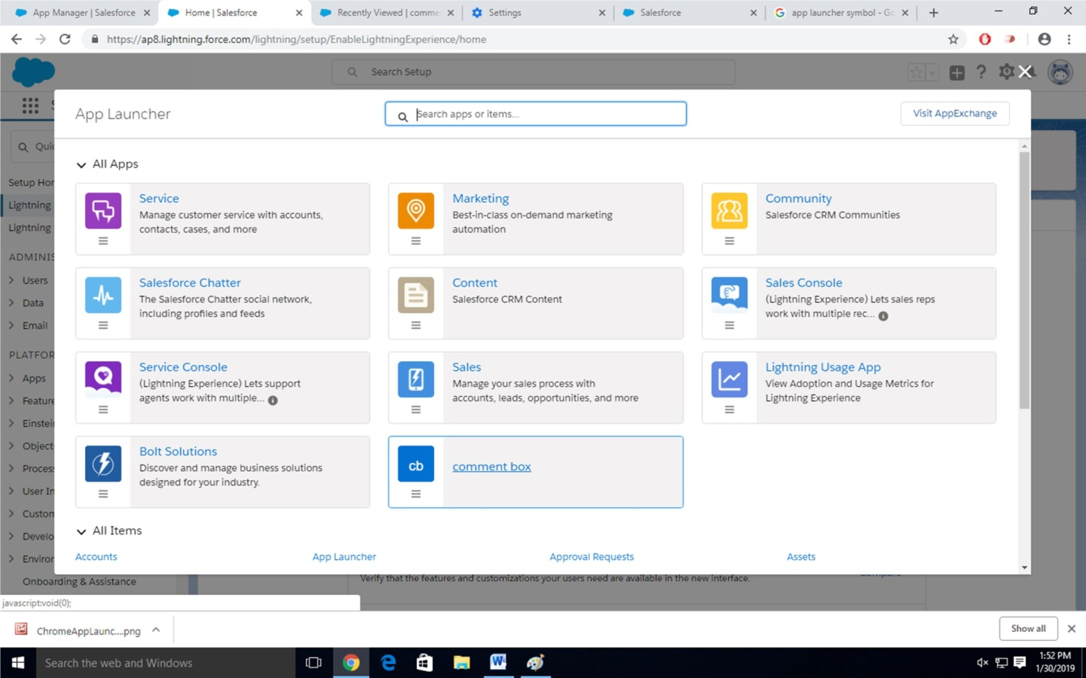

Step-11 Tour the app

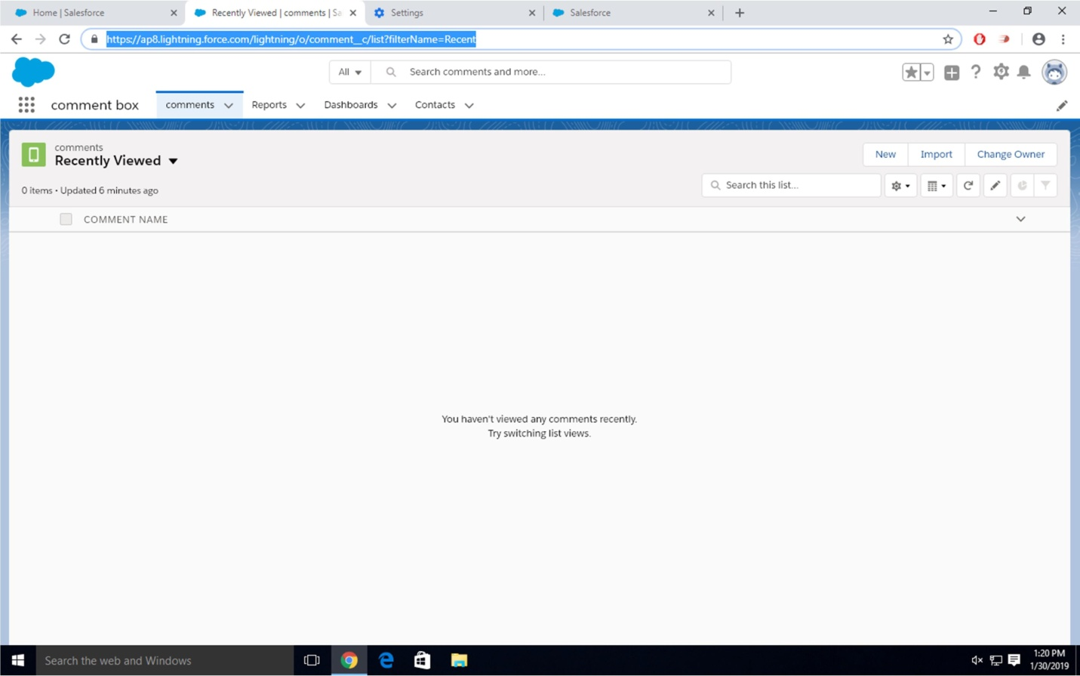

Step-12

Try out mobile app

-Select Chrome developer tools

-Open Chrome-Right Click on Chrome page- Select Inspect

-Click Toggle Device Mode Button to simulate your browser as a mobile device

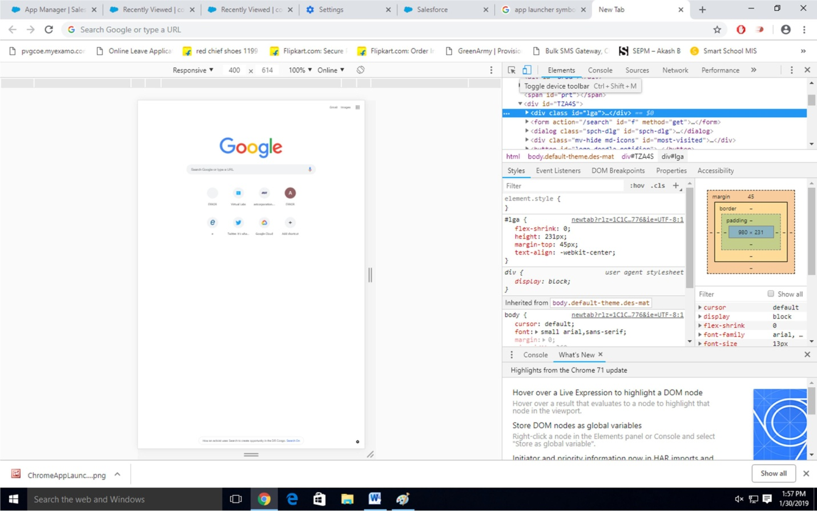

Step-13

To simulate the sales force mobile app in your browser, copy and paste in url from previous tab.Delete the part of the url immediately.

-Click on Left navigation bar

-Find comment object under recent and click on it

-Click new to create a comment

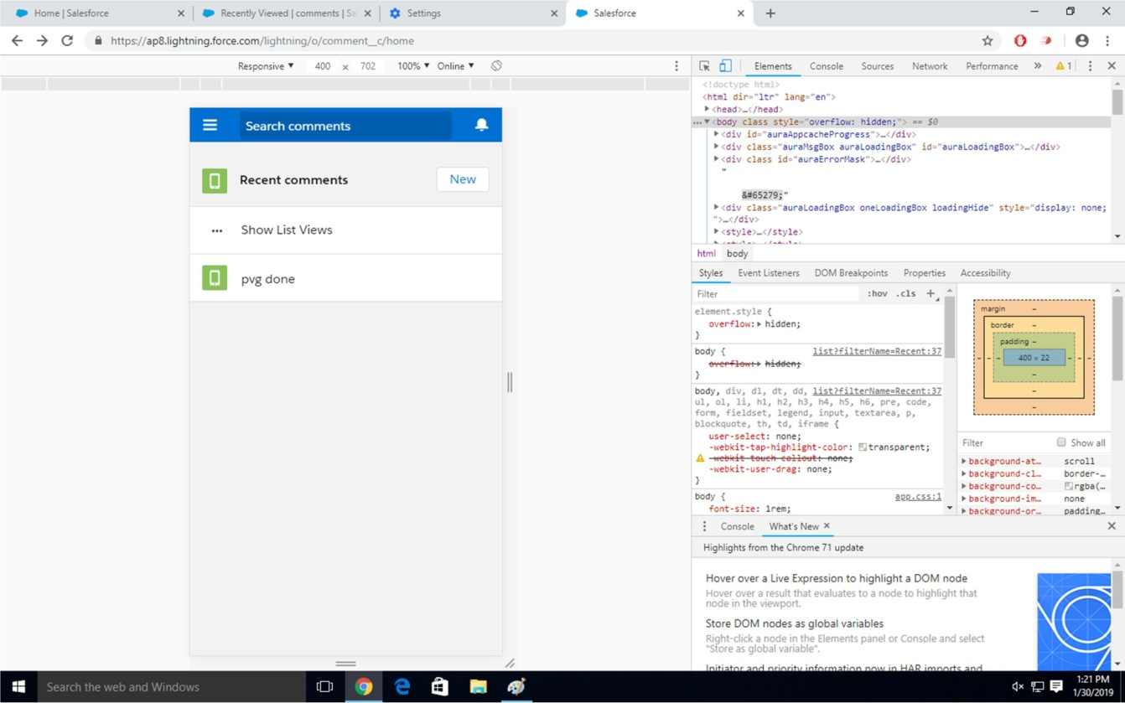

**Conclusion:** Thus, we have studied and understood the procedure to design and develop custom Application (Mini Project) using Salesforce Cloud.